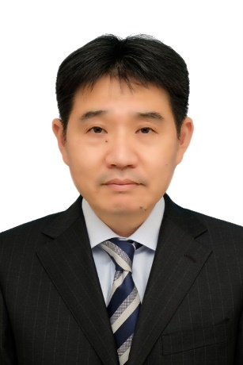

CURRICULUM VITAE

Full name:  Nationality: | Norimasa KURODA  Japanese
Date of birth:  Qualification: | 4 November 1968  Bachelor in International Economics, Yokohama National University
Employment history:

March 1991 | Graduation from the International Economic Department - Yokohama National University
April 1991 | Joining Nippon Petroleum (Tokyo Branch), Accounting Department
April 1996 | Working at the International Finance Division, Accounting Department
April 1999 | Working at the International Finance Division, Accounting Department  Nisseki Mitsubishi Company (post-merger rename)
April 2000 | Working at NIPPON OIL (U.K.) PLC
April 2004 | Working at Group 3, General Planning Department
April 2014 | Head of Support Team, Southeast Asia Sales Development Department
April 2015 | Head of Operation Team, Southeast Asia Sales Development Department
April 2017 | Working at Singapore Office, JXTG Nippon Oil & Energy Corporation Group (post-merger rename)
May 2018 | Vice Head of Accounting Department
June 2020 to now | Vice Head of Accounting Department, ENEOS Corporation (post-merger rename)
- End -

