PETROLIMEX | SOCIALIST REPUBLIC OF VIETNAM  Independence - Freedom - Happiness
CURRICULUM VITAE

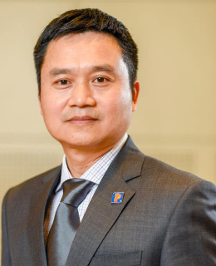 | - Full name:  - Nationality:  - Date of birth:  - Native place:  - Date of joining the Communist Party:  - Qualifications;  - Theoretical qualifications:  - Foreign language proficiency: | Pham Van Thanh  Vietnamese  8 December 1972  Chi Dao, Van Lam, Hung Yen  Probation: 26 September 2008  Official: 26 September 2009  MBA; Bachelor in Economics  Advanced  English (Certificate of Level C)
Training history:
- 1989 - 1993: | (Full-time regular) Bachelor in Economics/ major: Service Business Accounting, Thuongmai University
- 1992 - 1994: | (In-service) Bachelor in English, Hanoi Teacher Training University
- 2013 - 2015: | (In-service) Advanced Political Theory, Ho Chi Minh National Academy of Politics
- October, 2018 – June, 2020: | MBA - Andrews University

Employment history:
- 1 June 1993: | Social researcher of Non-Government Organization, Care International in Vietnam
- 3 October 1994: | Work at Sales Department of Oil Company
- 22 February 1995: | Official of Finance and Accounting Department, Petrolimex
- 3 March 1998 | Official of Internal Audit Department, Petrolimex
- 24 April 2000: | Short-term training (10 weeks) at Mekong Institute, Khon Kaen, Thailand
- 30 October 2000: | Official of Finance Department, Petrolimex
- December 2000- May 2001: | Trainee at BP Petco
- 1 July 2002: | Termination of Labor Contract with Petrolimex
- 2 October 2002: | Economist of Marketing Department, Bao Viet Insurance Corporation
- 1 March 2004: | Head of Marketing - General Affairs Division, PIACOM
- 16 June 2005: | Vice Head of Asset and Fire Department, PJICO
- 1 October 2005: | Head of Asset and Fire Department, PJICO
- 1 April 2009: | Director of the PJICO Hai Phong Branch - PJICO
- 1 April 2013: | Member of BOM, the General Director of Petrolimex Aviation
- 1 May 2018 - Now: | Chairman of the Board of Management, Petrolimex.

